Addition and Subtraction-Answers
Key Stage 3: 2003 Paper 1 Level 5-7
1.
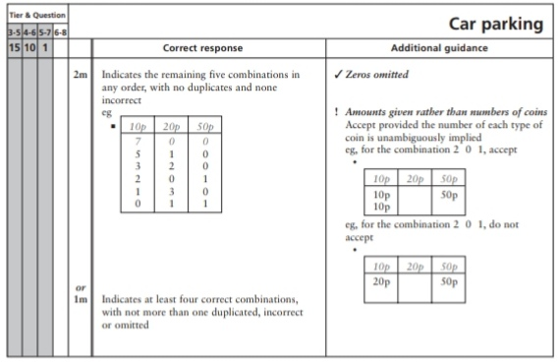
2.
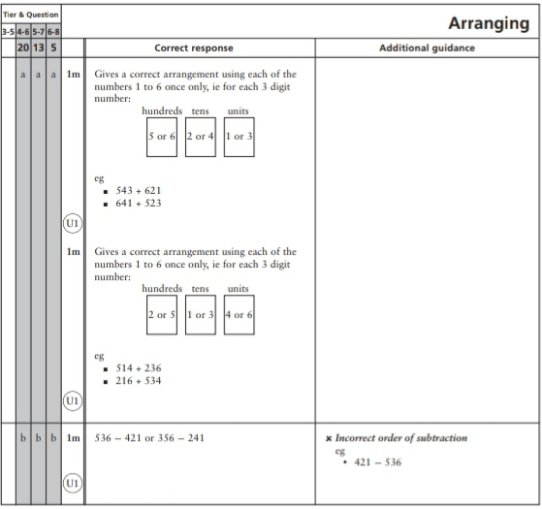
Key Stage 3: 2003 Paper 1 Level 6-8
3.
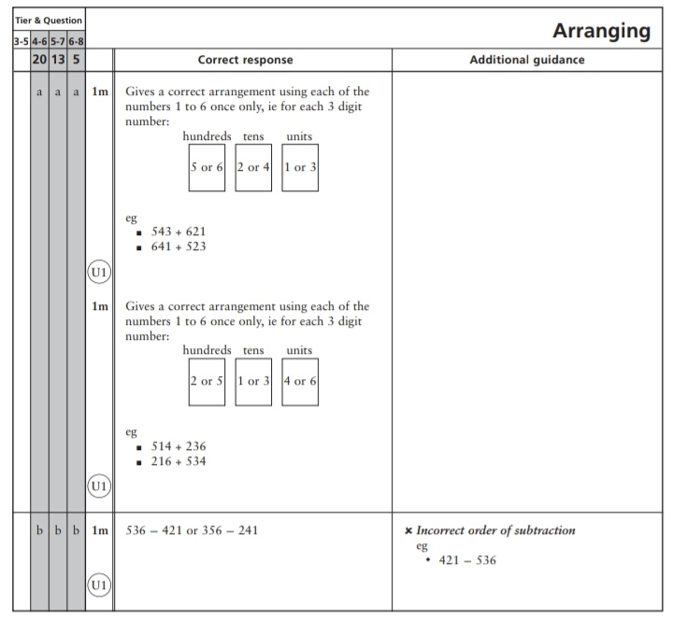
Key Stage 3: 2004 Paper 1 Level 5-7
4.
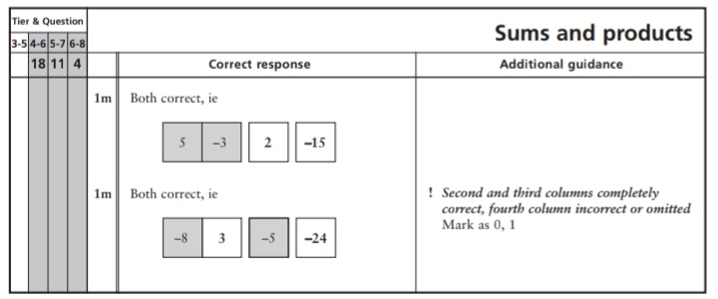
Key Stage 3: 2004 Paper 2 Level 5-7
5.
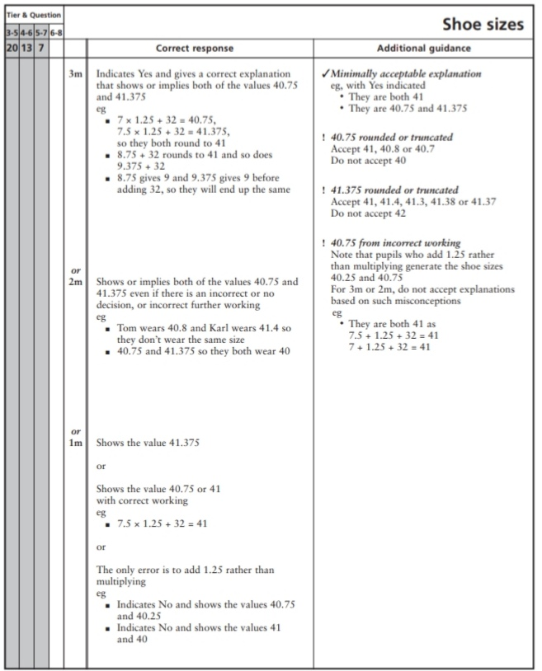
6.
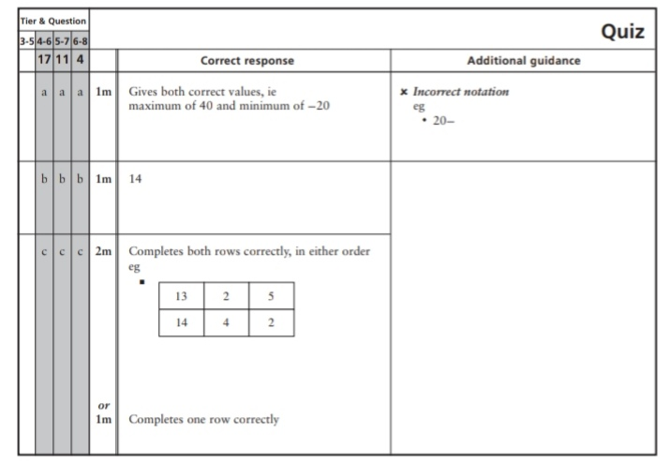
Key Stage 3: 2004 Paper 1 Level 6-8
7.
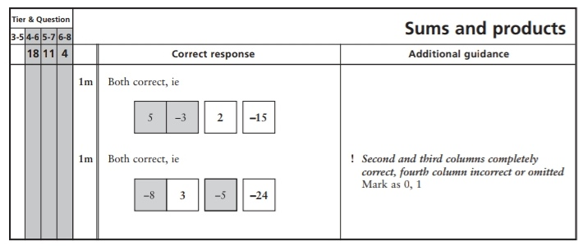
Key Stage 3: 2004 Paper 2 Level 6-8
8.
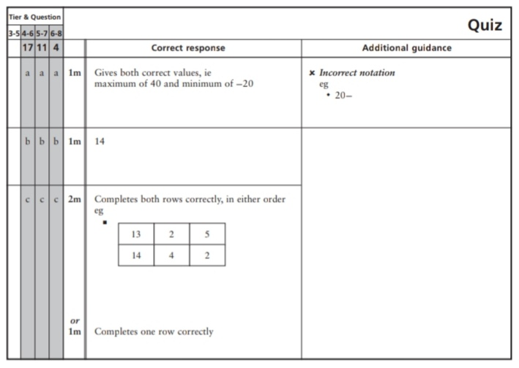
Key Stage 3: 2005 Paper 1 Level 5-7
9.
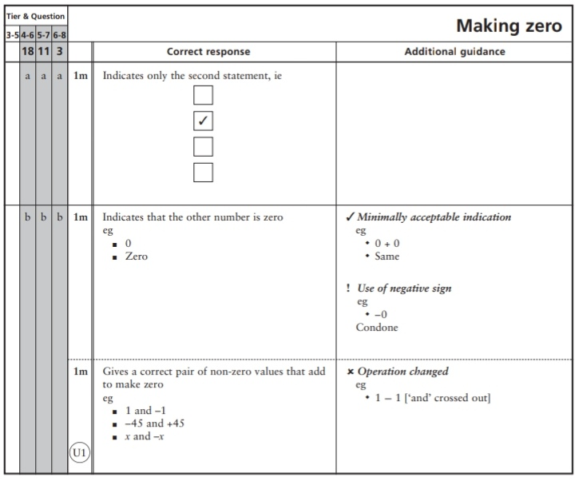
Key Stage 3: 2005 Paper 2 Level 5-7
10.
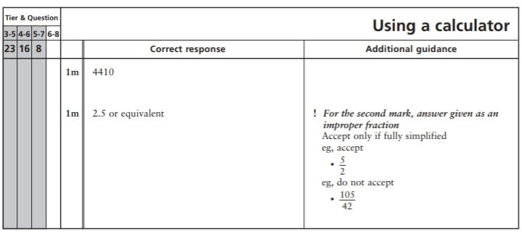
Key Stage 3: 2005 Paper 1 Level 6-8
11.
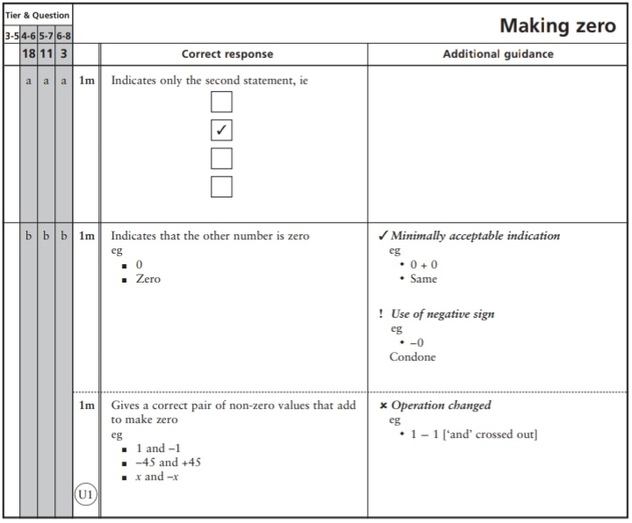
Key Stage 3: 2007 Paper 2 Level 5-7
12.
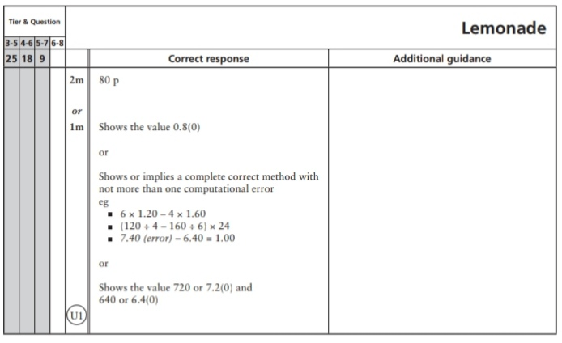
Key Stage 3: 2008 Paper 1 Level 5-7
13.
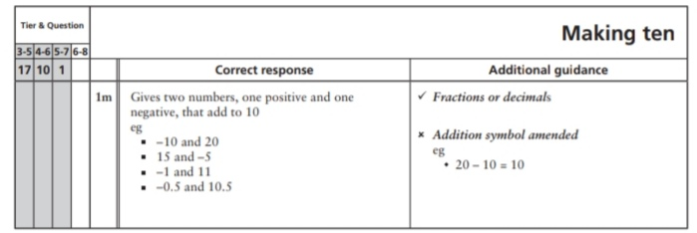
14.
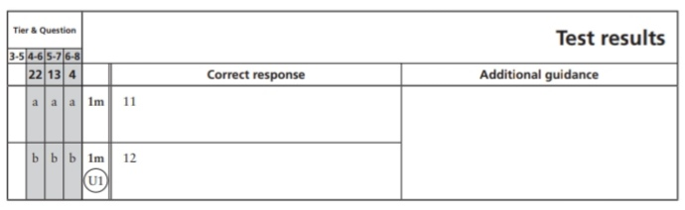
Key Stage 3: 2008 Paper 2 Level 5-7
15.
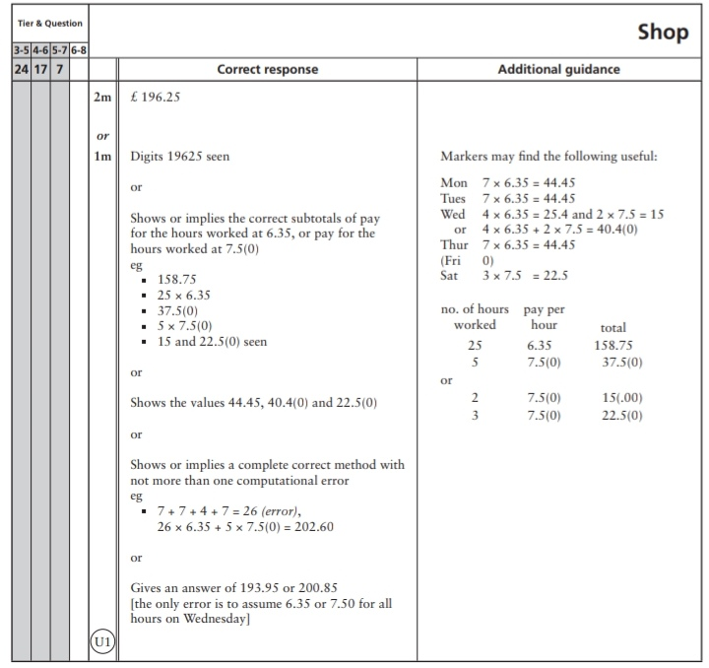
Key Stage 3: 2008 Paper 1 Level 6-8
16.
Key Stage 3: 2009 Paper 1 Level 5-7
17.
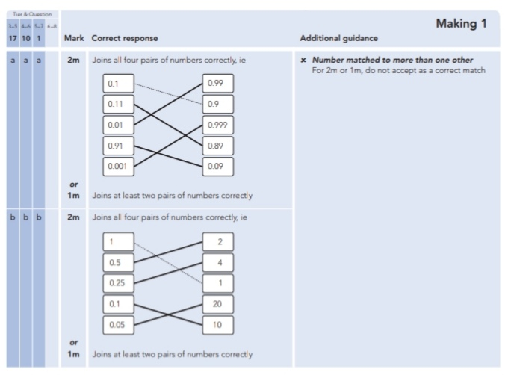
18.
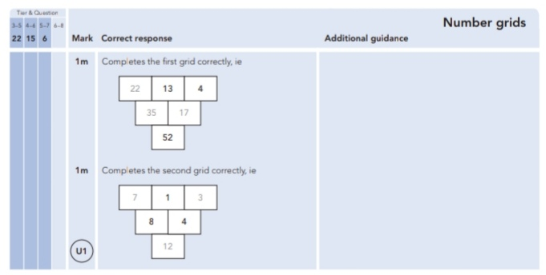
19.
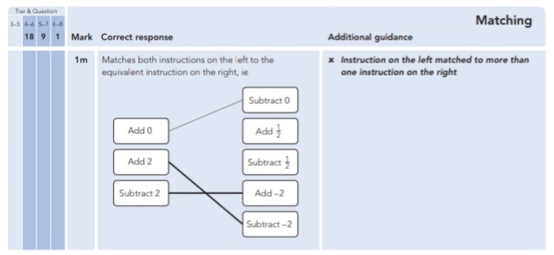
20.
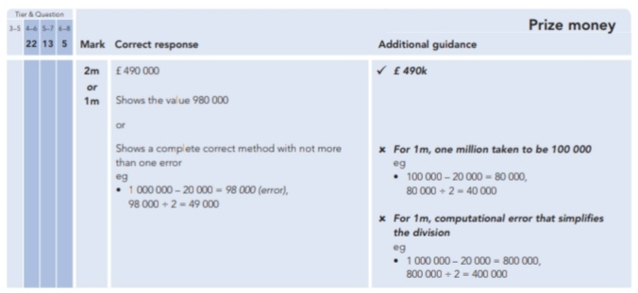
21.
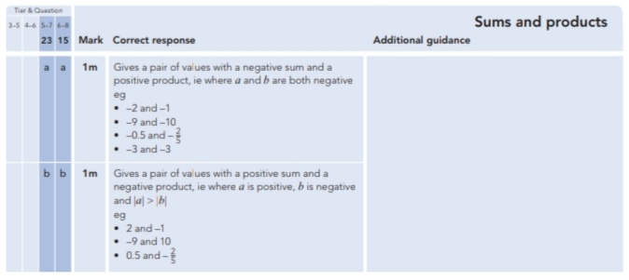

Key Stage 3: 2009 Paper 1 Level 6-8
22.
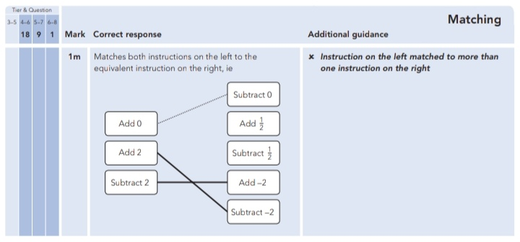
23.
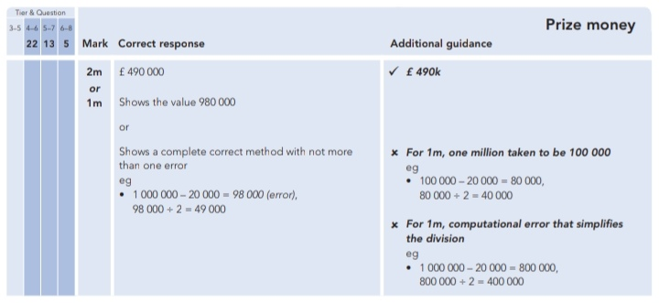
24.
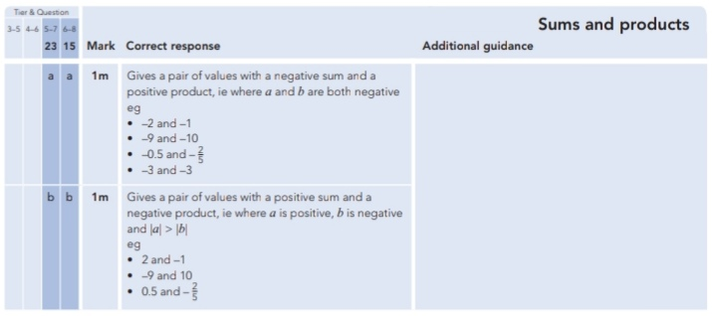
Key Stage 3: 2010 Paper 1 Level 5-7
25.
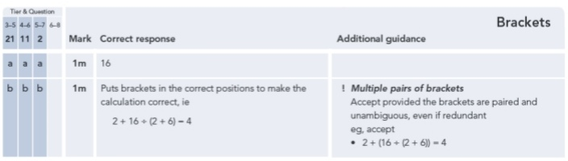
26.
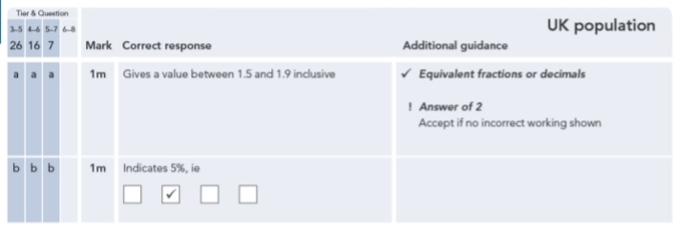
Key Stage 3: 2010 Paper 2 Level 5-7
27.
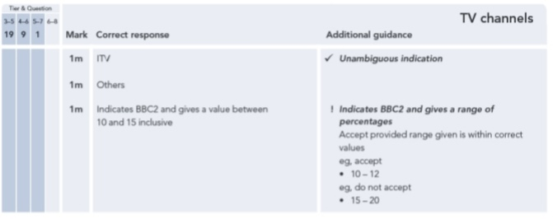
Key Stage 3: 2011 Paper 2 Level 5-7
28.
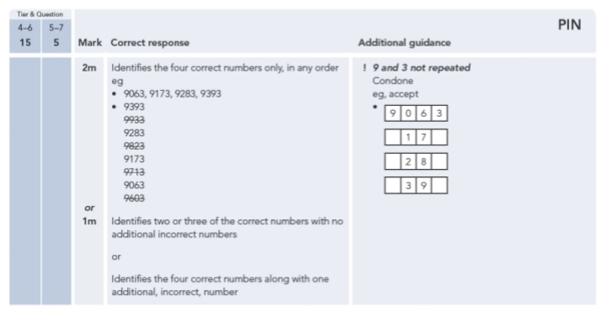
29.
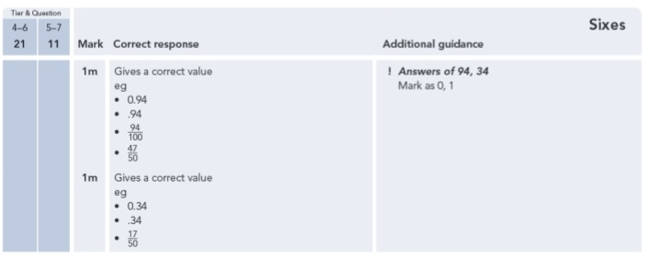
30.
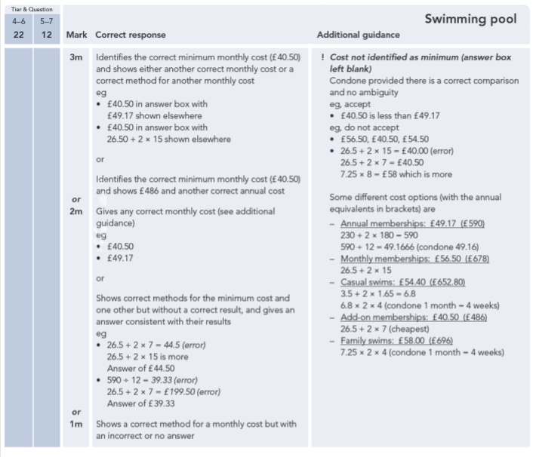
31.
